

SCHOOL OF COMPUTING AND INFORMATICS
DEPARTMENT OF INFORMATION TECHNOLOGY
BACHELOR OF SCIENCE IN INFORMATION TECHNOLOGY
COMPETENCY-BASED EDUCATION (CBE) ASSESSMENT APPLICATION
FINAL PROJECT DOCUMENTATION
DEVELOPED BY: AMOS MRAMBA KENGA
UNIT: MOBILE APPLICATION DEVELOPMENT
UNIT CODE:BIT4107

DATE: MAY 2026

1. Project Overview
The CBE Assessment Application is a native Android mobile application designed to facilitate the management and evaluation of learners within a Competency-Based Education framework. The system provides educators with a secure, offline, and localized platform to authenticate their credentials, register new students, and manage student rosters in preparation for individualized formative assessments such as observation checklists and grading rubrics.

2. Development Environment & Setup
The application was developed using Android Studio. The IDE and required Android SDK components were downloaded, unpacked, and successfully installed on the local machine to establish the development environment.
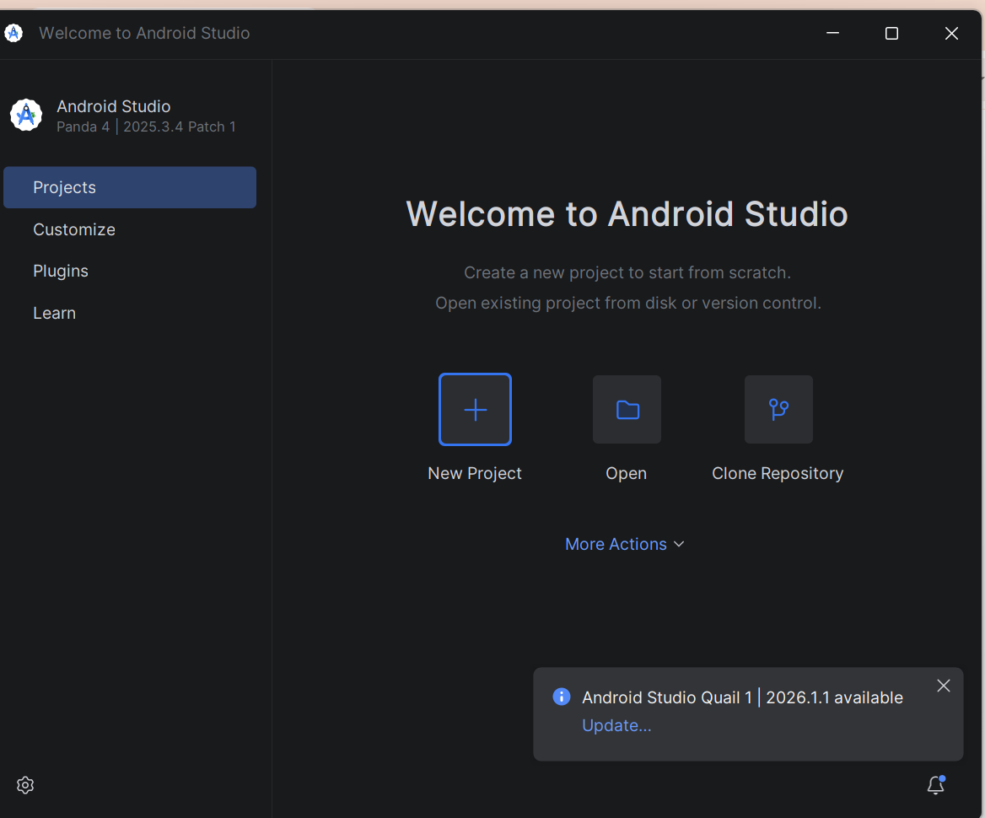
Following the installation, a new 'Empty Views Activity' project was initialized. The project was configured to utilize standard Java and target Android 7.0 (Nougat) as the minimum SDK. The project's AndroidManifest.xml was configured to properly register all application activities, ensuring seamless navigation across the system.
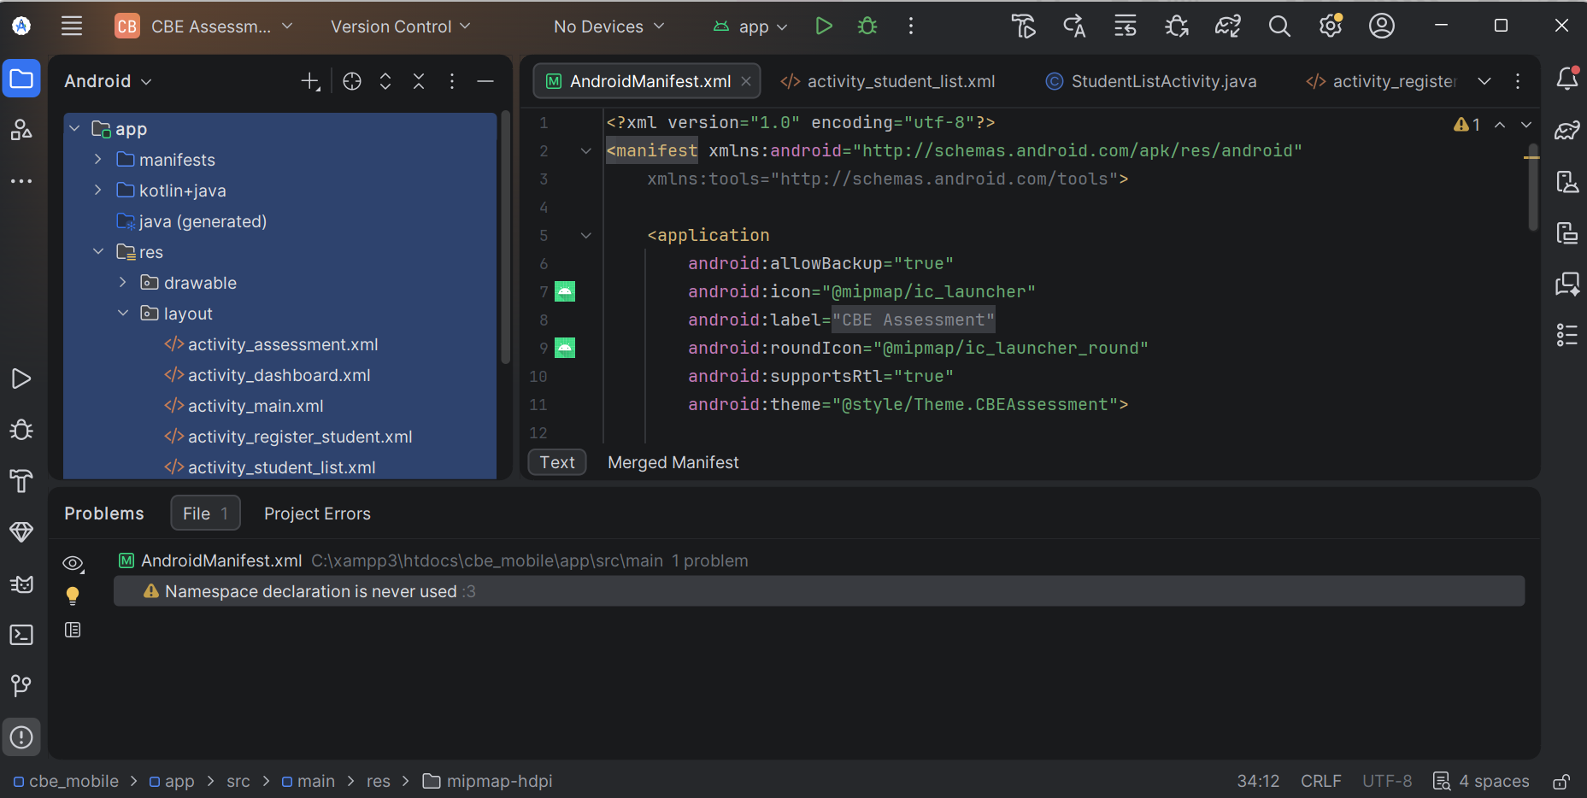

3. Technical Architecture
- Frontend UI: Built using eXtensible Markup Language (XML) to create responsive, native Android layouts (Linear and Constraint Layouts).
- Backend Logic: Developed in standard Java using Android SDK components (Activities, Intents, Adapters).
- Local Storage: Powered by an integrated SQLite relational database to ensure offline functionality, high-speed data retrieval, and secure local credential storage.

4. Database Schema
The local SQLite database (CBE_App.db) utilizes two primary tables to manage relationships between educators and learners.

Table: users (Educator Authentication)
Column Name | Data Type | Constraints | Description
ID | INTEGER | PRIMARY KEY, AUTOINCREMENT | Unique identifier for the user.
Email | TEXT | UNIQUE, NOT NULL | The educator's login email address.
Password | TEXT | NOT NULL | The educator's secure login password.

Table: students (Learner Roster)
Column Name | Data Type | Constraints | Description
Id | INTEGER | PRIMARY KEY, AUTOINCREMENT | Unique identifier for the student.
Name | TEXT | NOT NULL | Full name of the registered student.
admission_no | TEXT | NOT NULL | Unique school admission number.

5. Core Modules & Functionality
The application functionality is divided into several core modules. Below are descriptions of the key components, alongside critical visual representations of the mobile interface.

5.1 Authentication Module (MainActivity)
The entry point of the application acts as a secure gateway for educators. It captures user input, queries the SQLite database to verify credentials, and utilizes Android Intents to securely route authenticated users to the system dashboard.

5.2 Control Center (DashboardActivity)
Acting as the central navigation hub, the dashboard provides a clean interface for the educator's primary workflow. It routes the user to core areas: registering students, viewing rosters, and conducting assessments.
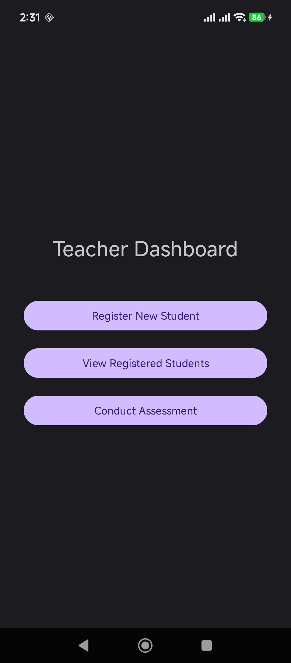

5.3 Learner Registration & Roster (RegisterStudentActivity & StudentListActivity)
A data-entry interface designed for rapid student onboarding. It validates inputs and pushes data into the students SQLite table. The roster management screen utilizes a Cursor to query these records and dynamically binds the data to an Android ListView for the teacher to review.

5.4 Assessment Integration (AssessmentActivity)
The core evaluation tool allowing the educator to conduct individualized formative assessments based on the CBE framework via interactive checklists.
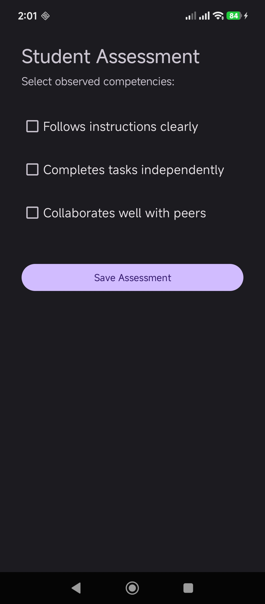

6. Future Enhancements (Phase 2 Roadmap)
- Assessment Interface: Linking the selected student from the StudentListActivity directly to specialized evaluation screens.
- Grading Rubrics: Interactive UI elements allowing teachers to evaluate students dynamically (e.g., Exceeding Expectations, Meeting Expectations, Approaching Expectations, Below Expectations).

